Calculate Your Net Worth - Full Answer

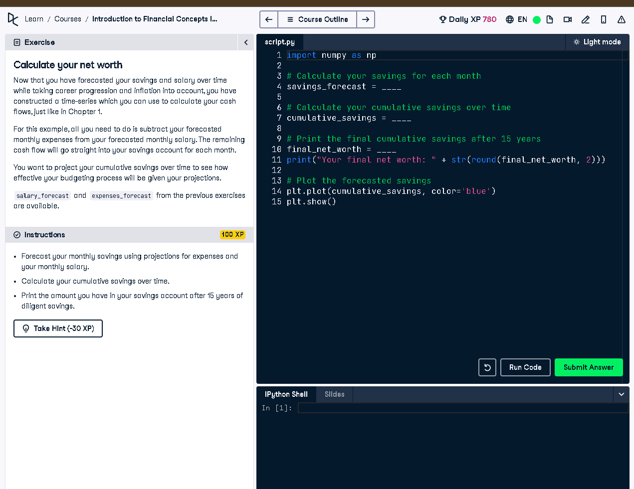

# Full Code Answer:

import numpy as np  
  
# Calculate your savings for each month  
savings_forecast = salary_forecast - expenses_forecast  
  
# Calculate your cumulative savings over time  
cumulative_savings = np.cumsum(savings_forecast)  
  
# Print the final cumulative savings after 15 years  
final_net_worth = cumulative_savings[-1]  
print("Your final net worth: " + str(round(final_net_worth, 2)))  
  
# Plot the forecasted savings  
plt.plot(cumulative_savings, color='blue')  
plt.show()

# Question:

How can you calculate and project cumulative savings over 15 years using salary and expense forecasts?

# 20-word Explanation (Question):

Cumulative savings projection helps visualize how income minus expenses accumulates over time, showing long-term financial health trends.

# Answer:

Subtract expenses_forecast from salary_forecast monthly, then apply np.cumsum to accumulate savings and determine final net worth.

# 20-word Explanation (Answer):

By subtracting expenses from salary each month and summing progressively, we estimate net worth growth over a 15-year span.